**Search Mission : Artemis**

En el año 2038, debido a una crisis climática en la tierra, la tripulación Artemis necesita ir en busca del planeta

In the 2018 year, due to a climate crisis in the earth, the Artemis crew need to go to the space to search the planet more feasible to live in. Because of that, they have studied 50 possible planets that can be the house of the humanity with the necessary resources. In addition, they have the fuel consumption data that it would cost to go from each planet to another, it is known that the ship has a maximum fuel capacity of 500,000 gallons, composed of kerosene and liquid oxygen, so it’s important to the crew consume the minimum possible amount of fuel.

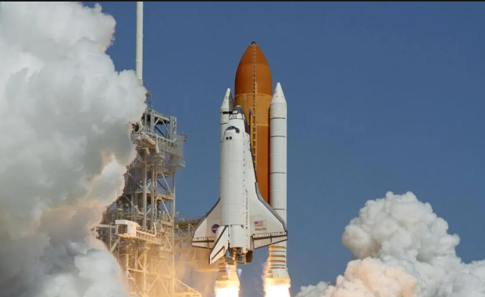

Artemis will constantly be changing planets, so it will always be necessary:

1. Upgrade the planet the crew is on.
2. Know if you can go to a specific planet from the planet you select, regardless of fuel.
3. Know the least fuel-consuming path from where you are to a desired planet and whether your current fuel is enough.

La NASA

The NASA has hired you and your software team to create an informatic solution for every requirement that they have. Also, Artemis, because of physical issues, know that between two planets there is only a possible direction of navigation and that a planet.

This is the map of the planets and their paths:

